# Terraform Installation Guide

Our first task is to **install** Terraform. To do this on Windows, let's **download the latest binary** from here: <https://developer.hashicorp.com/terraform/downloads>:

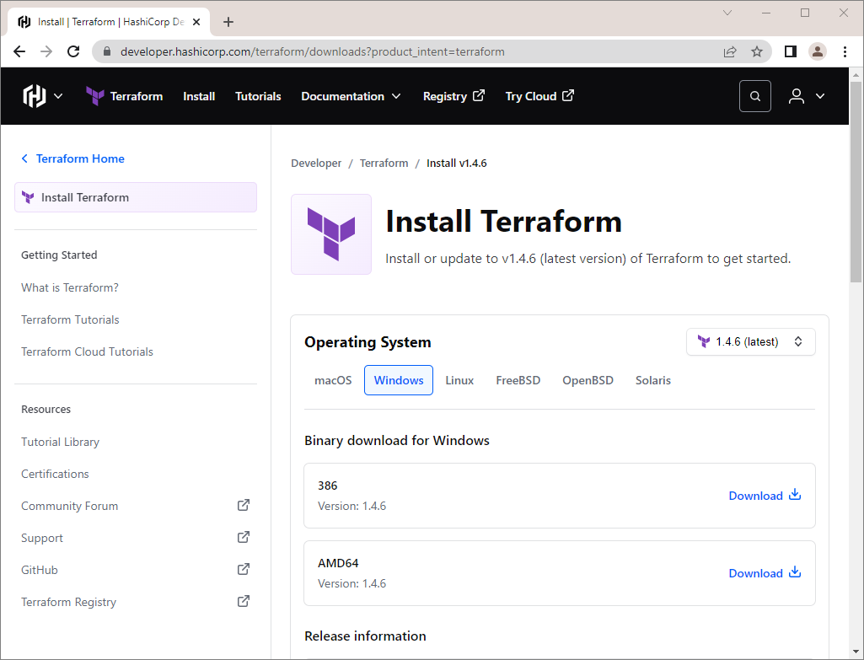

You have **downloaded a** .zip **file**, which you should **unzip**:

 🡪 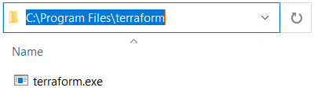

Terraform **runs as a single binary** named terraform.exe. Any **other files in the package can be safely removed** and Terraform will still function.

Now you should **add the path to the binary** in the PATH **environment variable**. To do this, **copy the file path** and go to "View advanced system settings" by searching for it or through the Control Panel:

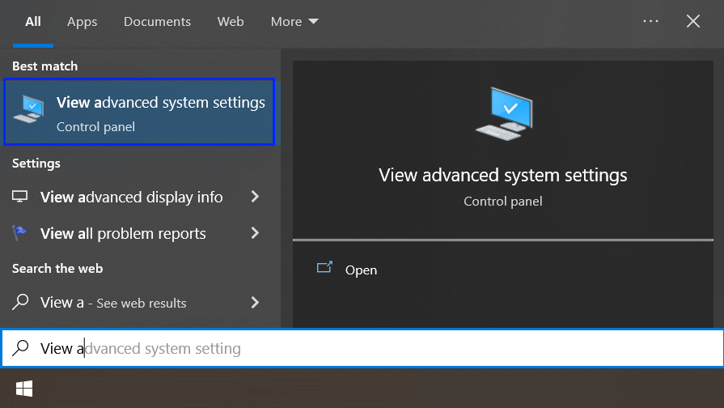

You should see the "System Properties" **window** and click on [Environment Variables]:

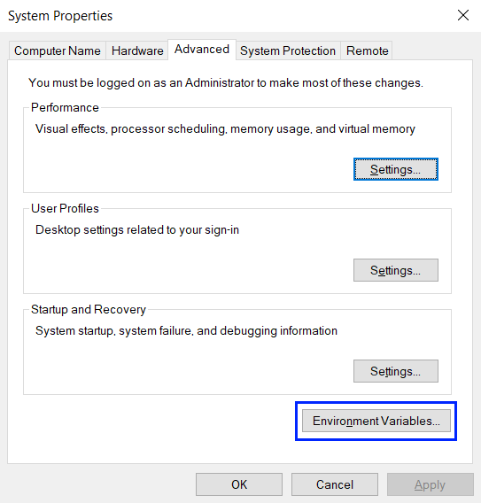

Next, click on the "Path" **variable** and on the [Edit] **button**:

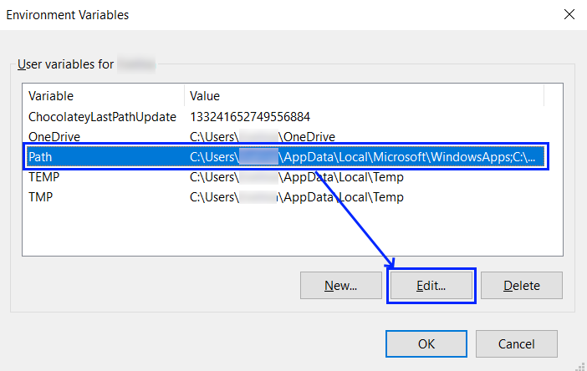

Then you should press the [New] **button** and **add the path** to where the terraform.exe **file** is:

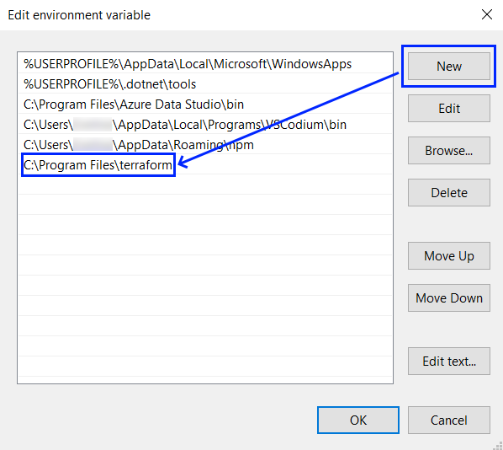

Click consecutively on [OK] **buttons** **to exit all settings**. At the end, let's **open a terminal** and **test if** Terraform **is installed** with the terraform -help **command** that **lists all available commands**:

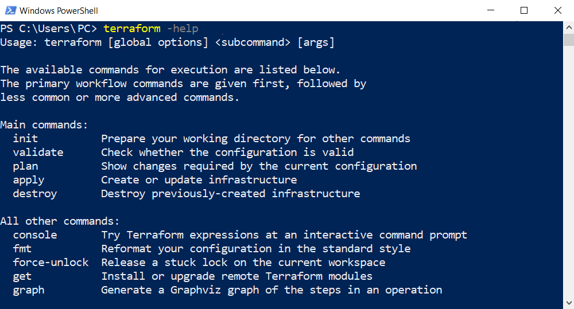



If you **receive any error**, it is probable that your PATH **environment variable was not set properly**.

Otherwise, **you now have** Terraform and you can go on with fulfilling the next tasks of this exercise.